Weekly Task Report
Geo Learn
11/13/19


Mentor: Fabio Santos
Sponser: Dr. Chris Doughty
Team members: Samuel Prasse (lead), Kaitlyn Grubb,
Tyler Pehringer, Joshus Tenakhongva

Weekly Team Task Report

Team: GeoLearn |  |  |  |  |  | Date: 11/13/19
Project Title: Improving elementary education with custom online enironmental science lectures

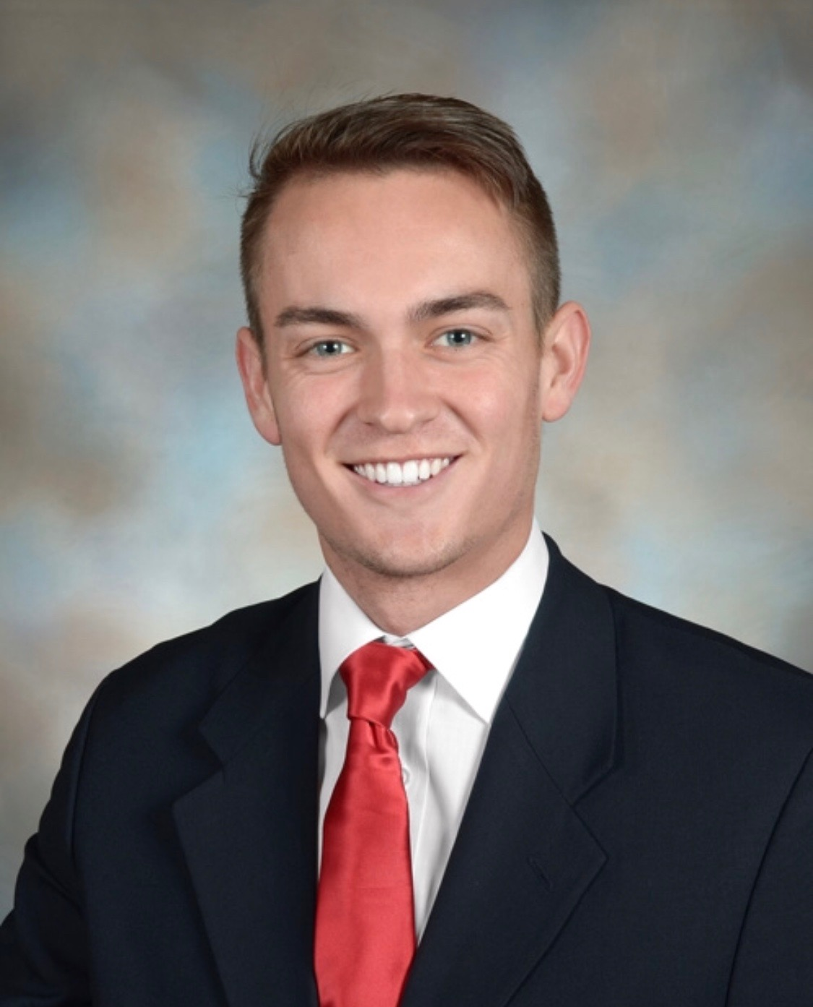 | Samuel Prassse  Present  On-time | 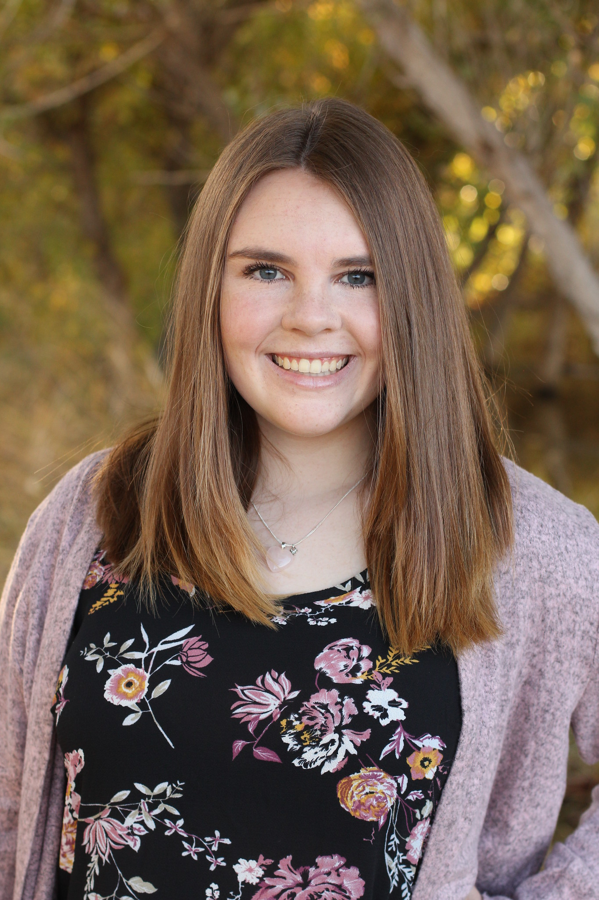 | Kaitlyn Grubb  Present  On-time | 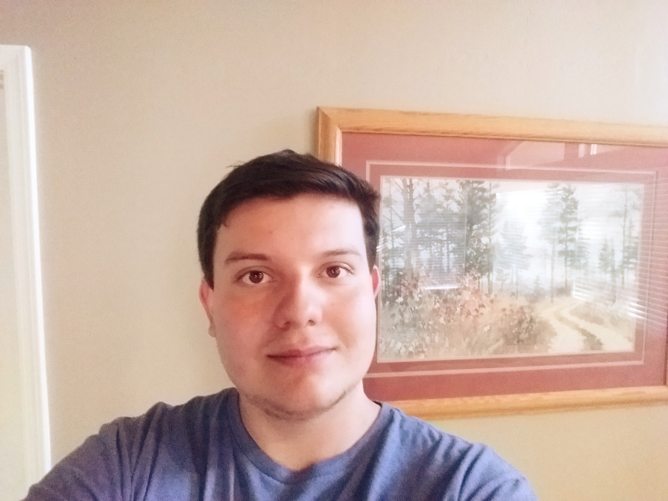 | Tyler Pehringer  Present  On-time |  | 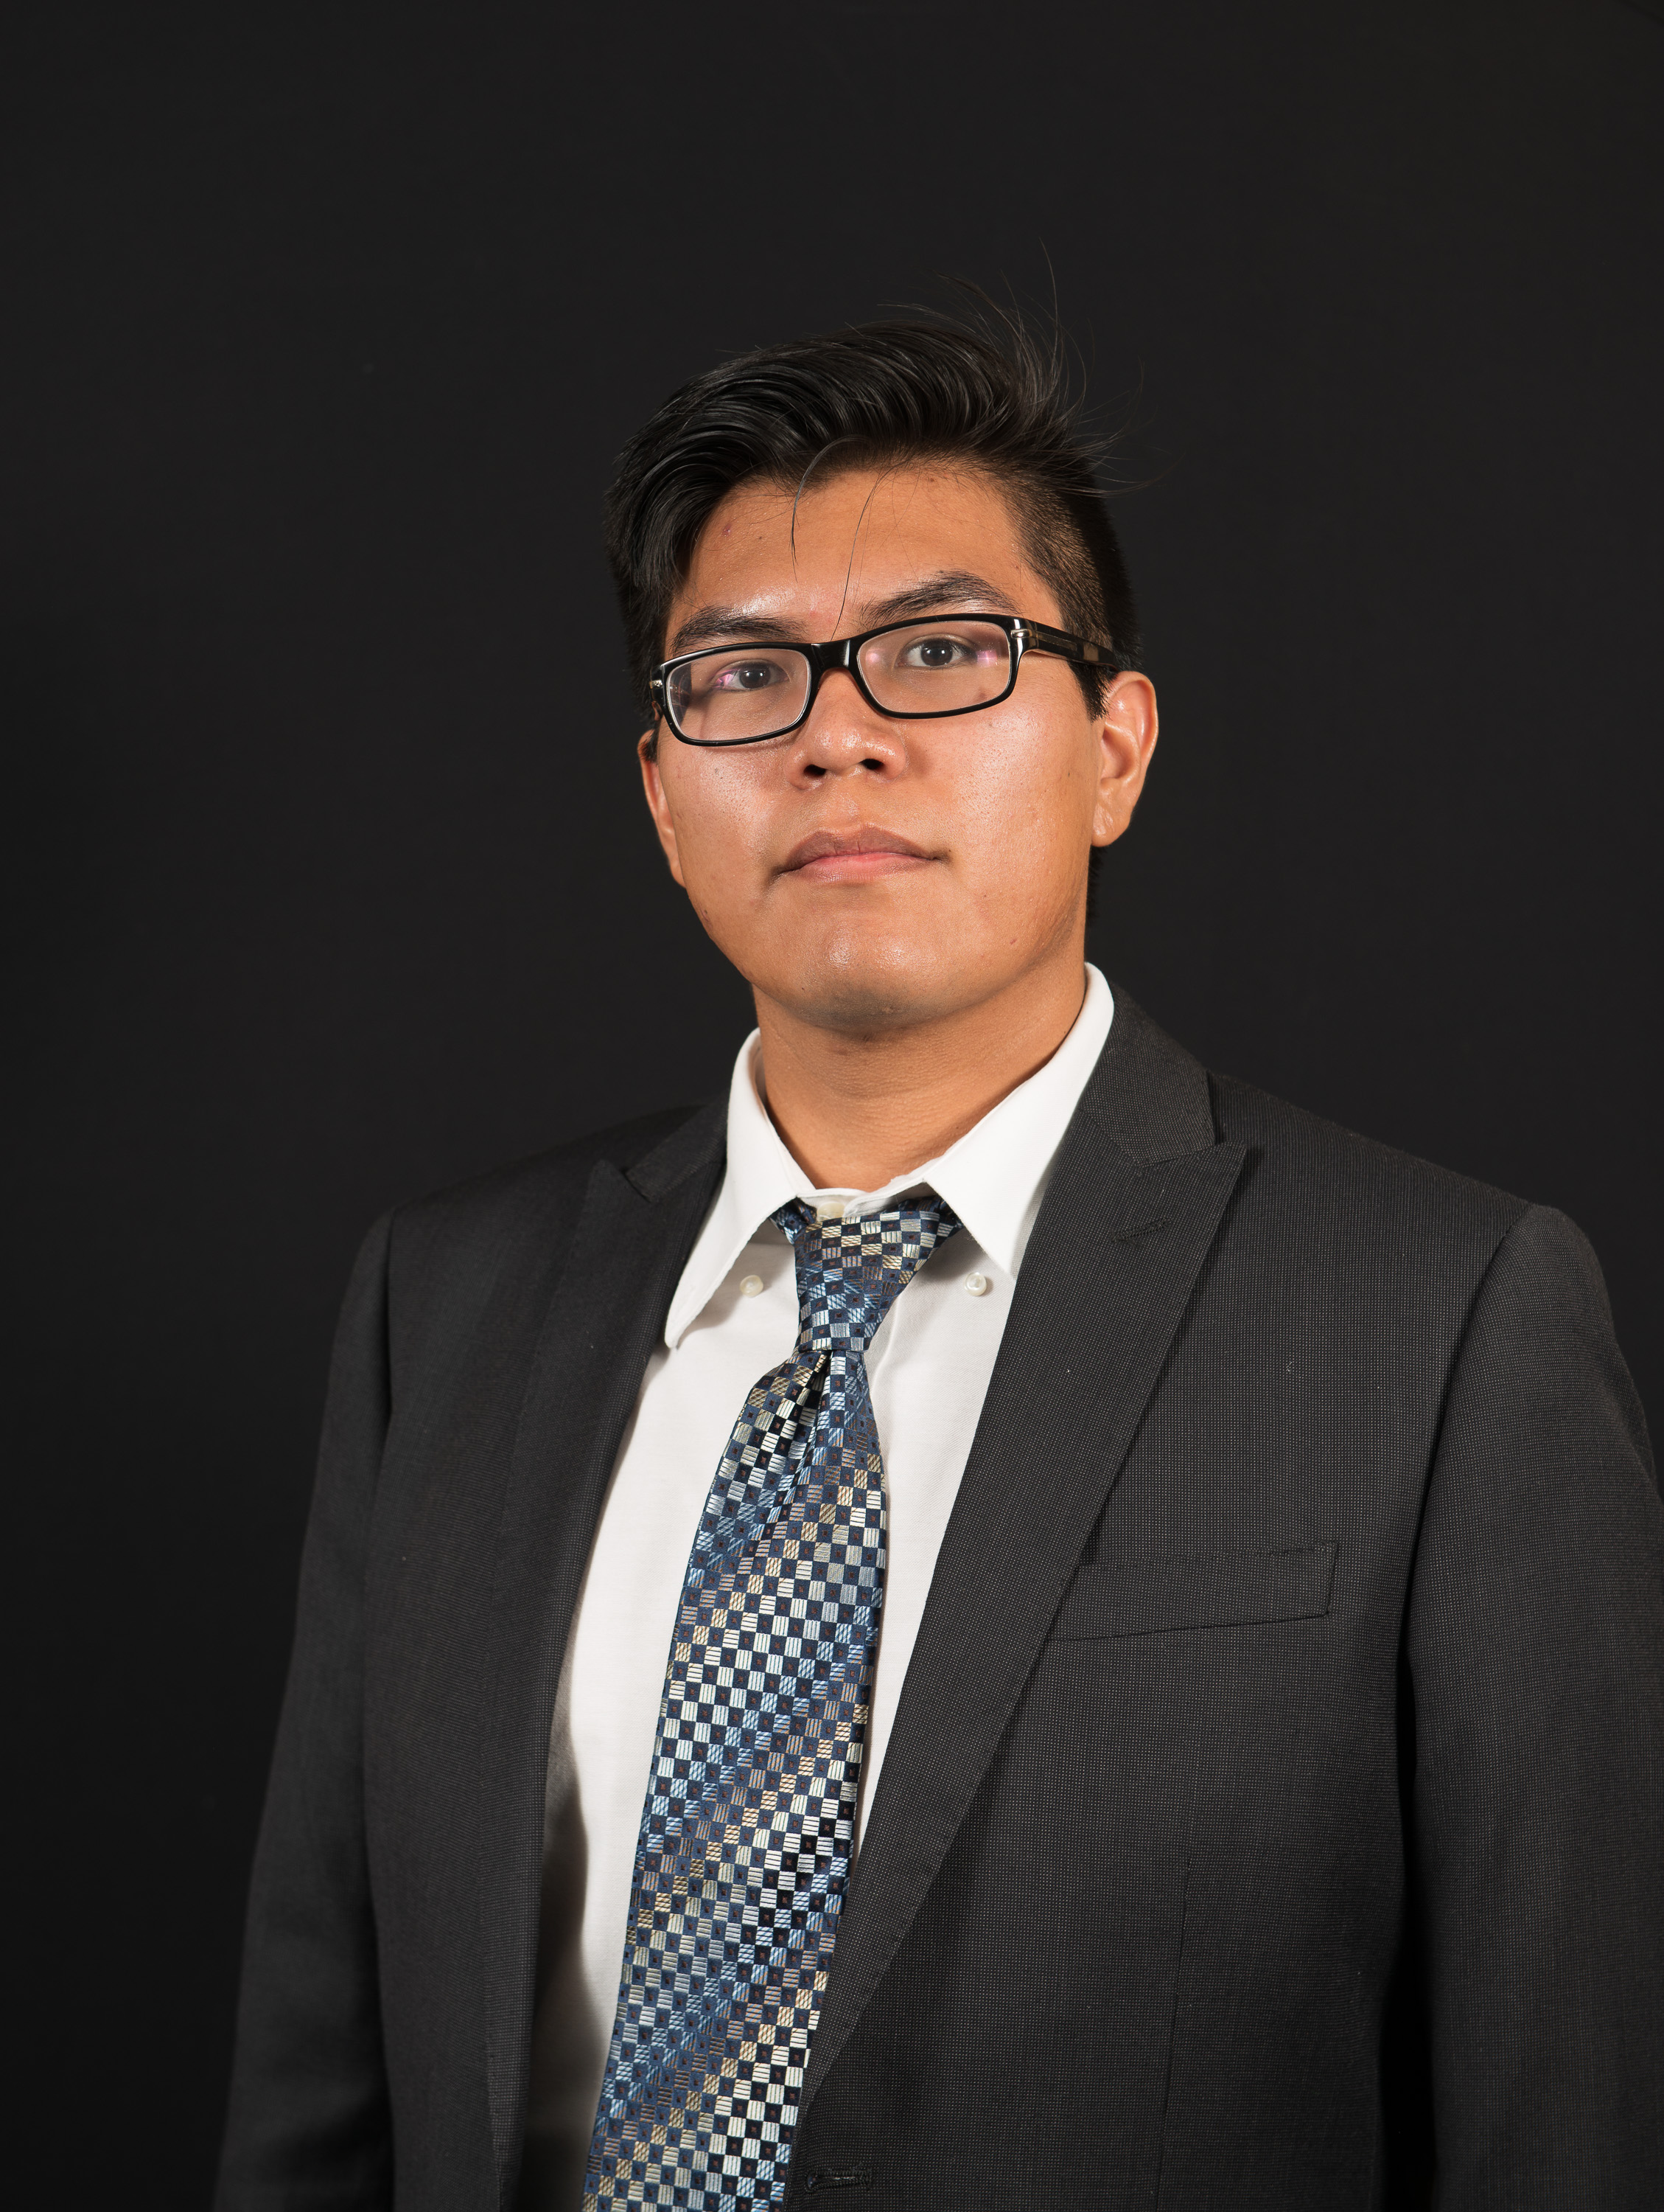 | Joshus Tenakhongva  Present  On-time

Recent Meetings:
- General Team Meeting
- Sponsor Meeting

TASKS COMPLETED since last meeting:

Task Title: Team Schedule | Task Initiation: 11/1 | Orig. Due Date: N/A | Status: Completed
Who (%): Team (100%)
Description: Worked on and completed the teams schedule for the remainder of the semester.
Expected Outcome: To have a list of required tasks to reference so the team maintains a high level of organization.

Task Title: 3 min Team Update | Task Initiation: 10/30 | Orig. Due Date: 11/8 | Status: Completed
Who (%): Joshus (25%), Kaitlyn (25%), Tyler (25%), Samuel (25%)
Description: Present our current status to the class during dedicated class time. This will include our tech feasibility document contents (very short overview) and our progress on our requirements document. Also will outline any important items as discussed in the prior weeks meetings with our mentor and sponsor.
Expected Outcome: A short but very informative presentation on our progress from the past month since our last presentation.

Task Title: Peer Eval | Task Initiation: 11/4 | Orig. Due Date: 11/8 | Status: Completed
Who (%): Team (100%)
Description: Each team member will fill out a peer eval and send it to Fabio by November 8th.
Expected Outcome: An accurate representation of effort and time invested by individual team members as graded by the other 3 team members.

This week’s Tasks: Work plan for coming week
Task Title: Requirements Specification | Task Initiation: 10/30 | Orig. Due Date: 11/22 | Status: In Progress
Who (%): Joshus (25%), Kaitlyn (25%), Tyler (25%), Samuel (25%)
Description: The requirements specification is a description of our project’s requiremtnts, both functional and non-functional, and forms the contractural basis for the expectations to be fulfilled by the development team.
Expected Outcome: Create a document outlining the requirements that the team will stick to when developing our project.

Task Title: Requirements Spec. Dry Run | Task Initiation: 11/11 | Orig. Due Date: 11/13 | Status: In progress
Who (%): Team (100%)
Description: The team will run through our Requirements Specification document with our mentor Fabio. This will take place on November 13th at 2pm in Cline Library. We have split up the document goals into several sections: Intro/Conclusion (Samuel), Schedule (Joshus), Problem Statement (Tyler), Solution Overview (Kaitlyn), and the team will split up the “Key Requirements” section.
Expected Outcome: Receive a review of our slideshow and edits from our mentor to ensure our document contains all the relevant information to get the best grade possible.

Upcoming Tasks: Planning
Task Title: Peer Eval #3 | Who (%): Team (100%) | Rough Due Date: 11/22
Description: An accurate representation of effort and time invested by individual team members as graded by the other 3 team members.

Other Problems / Other Issues:

